Air Boat

Subject:  Related Subjects: | Grade Level(s): 2,3,4,5,6,8  Length of Lesson: | Type: Inquiry / Design / Project  Keywords: Physics, Science/Math Involved, Newton’s Third Law, Center of Gravity, Circuits, Archimedes' principle, Buoyancy, balance, action-reaction, displacement

Lesson Overview
Use this section to describe at a high level what the lesson is. Should be no more than 3-4 lines.

Lesson Focus
What is the central question or phenomenon being investigated? What problem are they trying to solve?

Lesson Objective(s) | Students will create an airboat, which will float and move in water.

Lesson Timing

5 minutes | Introduce the Lesson
30 minutes | ...

Materials | - –1.5v motors  - –¼” wood dowels  - –Toggle switches  - –Propellers  - –Insulated wire  - –Single battery holders  - –Light plastic container or 1L bottles  - –Wire strippers  - –AA batteries  - –Hot Glue Gun  - –Glue sticks  - –Soldering Iron  - –Solder
Instructor Prep | - Step 1
Related Resources | - List related lessons/ppts etc available from USC or outside, trusted orgs

Lesson Plan

Introduction

Boats have been around almost as long as humans have lived by the sea. In the late 1700’s, steamboats became among the first motor powered boats. The early 1900’s brought about the airboats, floats with motors elevated above water to create motion by circulating wind.
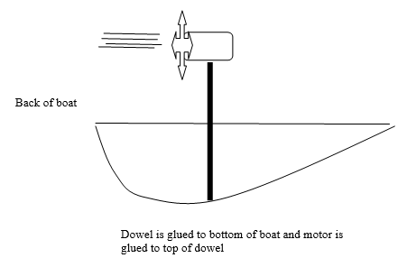

Procedure
- – Strip wires
- –Cut a 3 to 5-inch wood dowel (depending on boat frame)
- –Glue dowel to center of boat frame
- –Insert one wire to one clip on motor
- –Insert other wire in other clip on motor
- –Solder wires to motor
- –Attach propeller to motor
- –Test motor with battery to see which end positive battery must touch to make propeller blow air toward you.
- –Place small piece of tape on wire which should be connected to positive end of battery
- –Solder taped wire to center hole in switch
- –Solder red wire from battery holder to either outside hole on switch
- –Twist remaining wires and tape
- –Glue motor to top of dowel with propeller facing the back of boat frame.
- –Glue switch to side
- –Glue battery holder to whichever part of boat frame, which maintains balance.
- –Place in shallow pool of water.
- –Check for stability and balance.
- –Flip the switch.

Wrap-up
End the lesson with some final discussions about what students designed/discovered. Connect their activity back to the focus question/problem, real world examples, and STEM careers.

Also include notes about any special cleanup considerations

Lesson Background for Teachers

Suggested Real-World STEM Connections
- List possible related Role Models in STEM (with details and links to more reading). Give suggestions for examples of scientists/engineers who are from underrepresented groups in STEM in related careers.
- List related real-world engineering problems and examples

Lesson Variations and Options
Include descriptions of alternative methods or ways to present things.

Explanation
Describe the background concepts and explanations behind the lesson. This can be more in depth than a teacher/instructor would actually share with students.

Key Concepts and Vocabulary
- Word 1: Grade Appropriate Definition
- Word 2: Grade Appropriate Definition

Safety Notes
- Safety instruction

